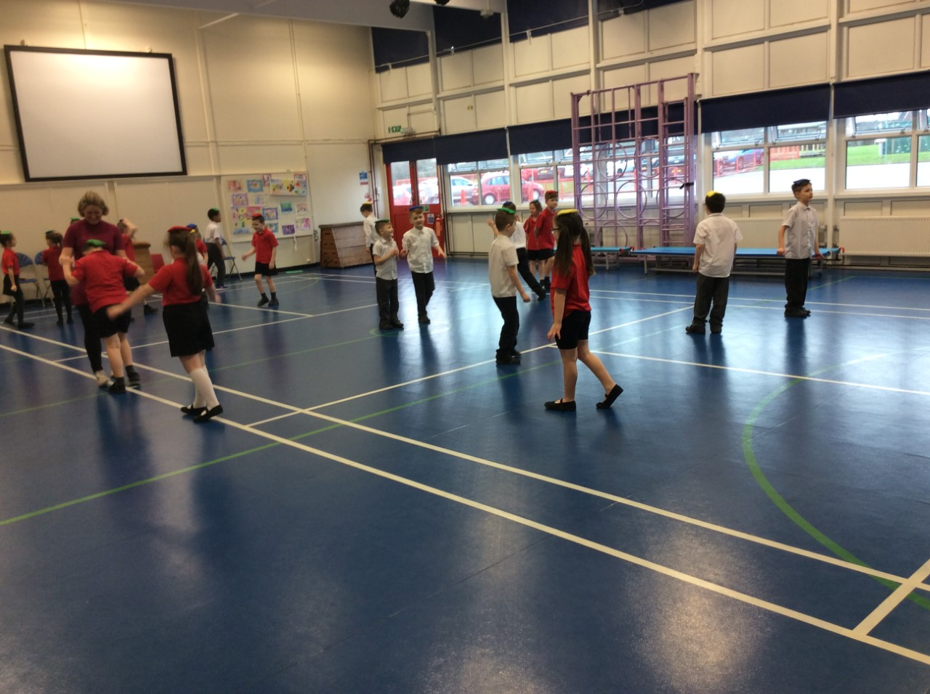

What is the Sports Premium?
PE and Sports Grant
The government is providing additional funding of £150 million per annum for academic years to improve provision of physical education (PE) and sport in primary schools. This funding - provided jointly by the Departments for Education, Health and Culture, Media and Sport – has been allocated to primary school head teachers.
This funding is ring-fenced and therefore can only be spent on provision of PE and sport in schools.

Purpose of funding
Schools must spend the additional funding on improving their provision of PE and sport, but schools have been given the freedom to choose how they do this. A list of possible uses has:
Possible uses for the funding include:
- hiring specialist PE teachers or qualified sports coaches to work alongside primary teachers when teaching PE
- new or additional Change4Life sport club
- paying for professional development opportunities in PE/sport
- providing cover to release primary teachers for professional development in PE/sport
- running sport competitions, or increasing participation in the school games
- buying quality assured professional development modules or materials for PE/sport
- providing places for pupils on after school sport clubs and holiday clubs

Millbrook Priorities:
Priority 1- To ensure all children have access to high quality PE teaching and resources.

Priority 2- To identify and implement an assessment process which assesses pupils progress in PE.

Priority 3- Raise the profile of PE across the school.

Priority 4 – To increase our range of extra curricular sporting activities and encourage increased participation in competitive sporting activities for all pupils.

Priority 5 – To further develop the schools healthy active lifestyle initiatives.

At Millbrook we offer a large variety of sports and extracurricular activities. We aim to continue offering all of our children the opportunities to take part in a range of sports at inter, intra and county level. These include:
*Football (boys and girls) *Basketball *Tag Rugby *Cross Country
*Indoor Athletics *Outdoor Athletics *Gymnastics *Fencing *Dodgeball *Swimming *Boccia *Dance *Table Tennis *Cycling *Military style problem solving and team building *Canoein*Hill walking

The Sports Plan for 2016-2017
Sports Grant Received:- £8000

Total Number of Pupils on roll = 290

Objective:- To effectively use the sports grant to raise the profile and outcomes for children in PE, sport and physical activity across the school

TARGETS AND PRIORITIES | TIMESCALE | RESPONSIBILITY | RESOURCE IMPLICATIONS
Buying into Knowsley School Partnership | October 2016 | HT | £900
The profile of PE and sport being raised across the school as a tool for whole school improvement. | March 2017 | NL and BW-  Set up school blog on games website.
CPD for Staff in raising confidence in teaching  - Audit current needs  - Facilitate through partnership | Audit complete November 2016 | NL and All teachers | Supply costs and training fees £1000
To introduce new planning throughout the school and ensure every class is following the same scheme | Feb 2017 | NL | New planning £500  Staff meeting time to show teachers  NL to complete learning walks to ensure everyone is confident in teaching the new scheme. £100- supply
Re-write and trial new assessment sheets based on Quigley for each strand and track each individual pupil through their school life.  Discussions with PE staff from other schools to take place about them. | March 2017 | NL and all staff | Supply cost for NL  Staff meeting time
Opportunities to bring in coaching staff throughout the year for KS1 and KS2 during lesson time | Ongoing throughout the year. | NL and All teachers | Coaching fees  £2000
Regularly updating PE resources in line with the New Curriculum | November audit and requisition  March order and requisition | NL  NL | £2000
Employing a local coach to provide weekly after school sport on school site and at the local club on evenings, and school holidays – Will and Phil | Aut 2016 | NL | £1000
Increased participation in competitive sport. | Ongoing | ALL STAFF | Cost of transport if needed.  Cost of outside teaching for certain sports. £500

