Teaching and Learning at Millbrook Primary School

Aims and Purposes
To raise standards at Millbrook Primary School by improving the quality of teaching and learning that takes place on a daily basis.
The expectation is that all pupils are provided with high quality learning experiences that lead to consistently high levels of pupil achievement.

Through a whole school approach to teaching and learning we aim:

- To provide consistency of teaching and learning.
- To enable teachers to teach as effectively as possible.
- To enable children to learn as effectively as possible.
- To give children the skills they require for lifelong learning.
- To provide an inclusive education for all.
- To learn from each other, through a collaborative approach to teaching and learning, where good practice is shared.

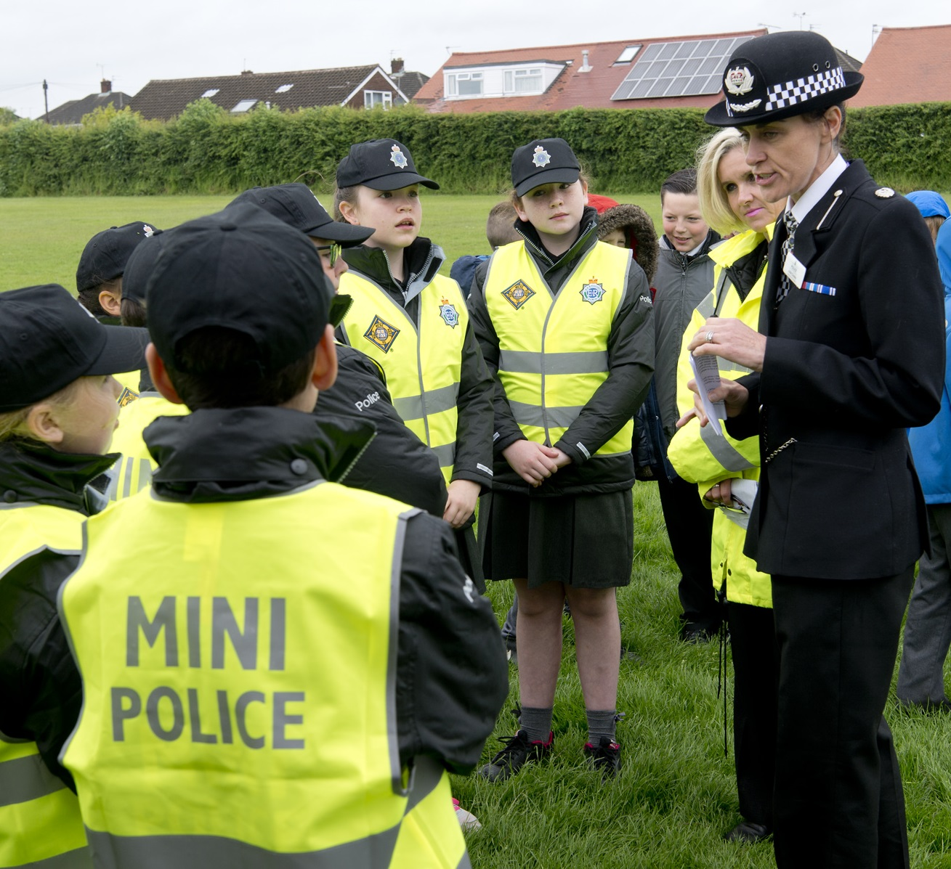

Key Themes for Effective Teaching and Learning
This policy outlines the key elements that will ensure we have high quality learning and development for all the children in our school.

The unique child
At Millbrook Primary School we will inspire children to meet their full potential as learners. Children will be enthusiastic and reflective learners. They will be well motivated and demonstrate stamina and resilience in their own learning. Children at Millbrook Primary School will develop their independence as learners through well informed feedback from all staff allowing them to clearly know and understand their next steps for learning.

Positive Relationships
All staff will ensure positive relationships through high quality interactions with children throughout the day in all areas of the school. All adult/child interactions will aim to support and challenge children as learners, ensuring all opportunities for learning are fully exploited. All relationships will demonstrate mutual respect at all times.
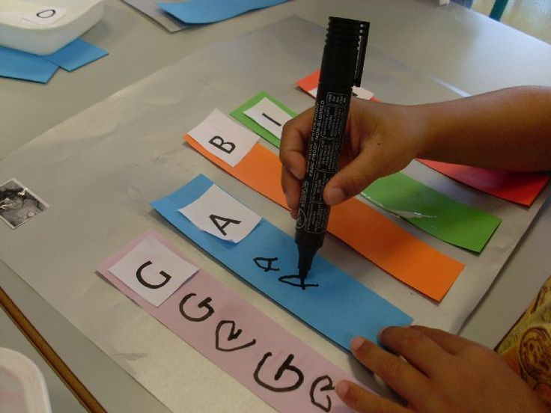
Enabling Environments
Our school will provide a stimulating environment for children to grow as learners. Resources and equipment will be stimulating and relevant. Enrichment experiences will support a creative curriculum. All members of our school community will value our learning environment.

All lessons will have...
- Clear learning intentions shared orally and displayed.
- Marking which reflects the learning intention.
- Well planned success criteria, so all pupils are clear about how they will achieve the learning intention.
- Success criteria which guides the learning intention, supports the marking and self assessment.

All lessons are...
- Planned and show clear differentiation to enable all children to access learning.
- Resourced with appropriate materials/apparatus that support the needs of all, groups and individual children.
Teachers and all adults will...
- Have high expectations of pupils learning and behaviour.
- Expect children to work hard.
- Challenge children in their learning.
- Encourage and promote independence
- Celebrate success.
- Know where children currently are and share next steps for learning.
- Use questioning to deepen understanding and consolidate learning.
- Take into account children’s concentration span and plan activities to ensure pupils are not sitting passively.

Pupils will
- Actively engage enthusiastically during all parts of the lesson.
- Actively engage in learning through collaborative learning such as Talk Partners.
- Be taught active listening skills and behave appropriately when engaged in partner discussion.
- Demonstrate appropriate stamina during tasks and generally work hard to improve their attainment.
- Have high expectations for their presentation skills and use appropriate resources to ensure their work is always well presented.
- Adopt good posture whilst they are writing at their tables.

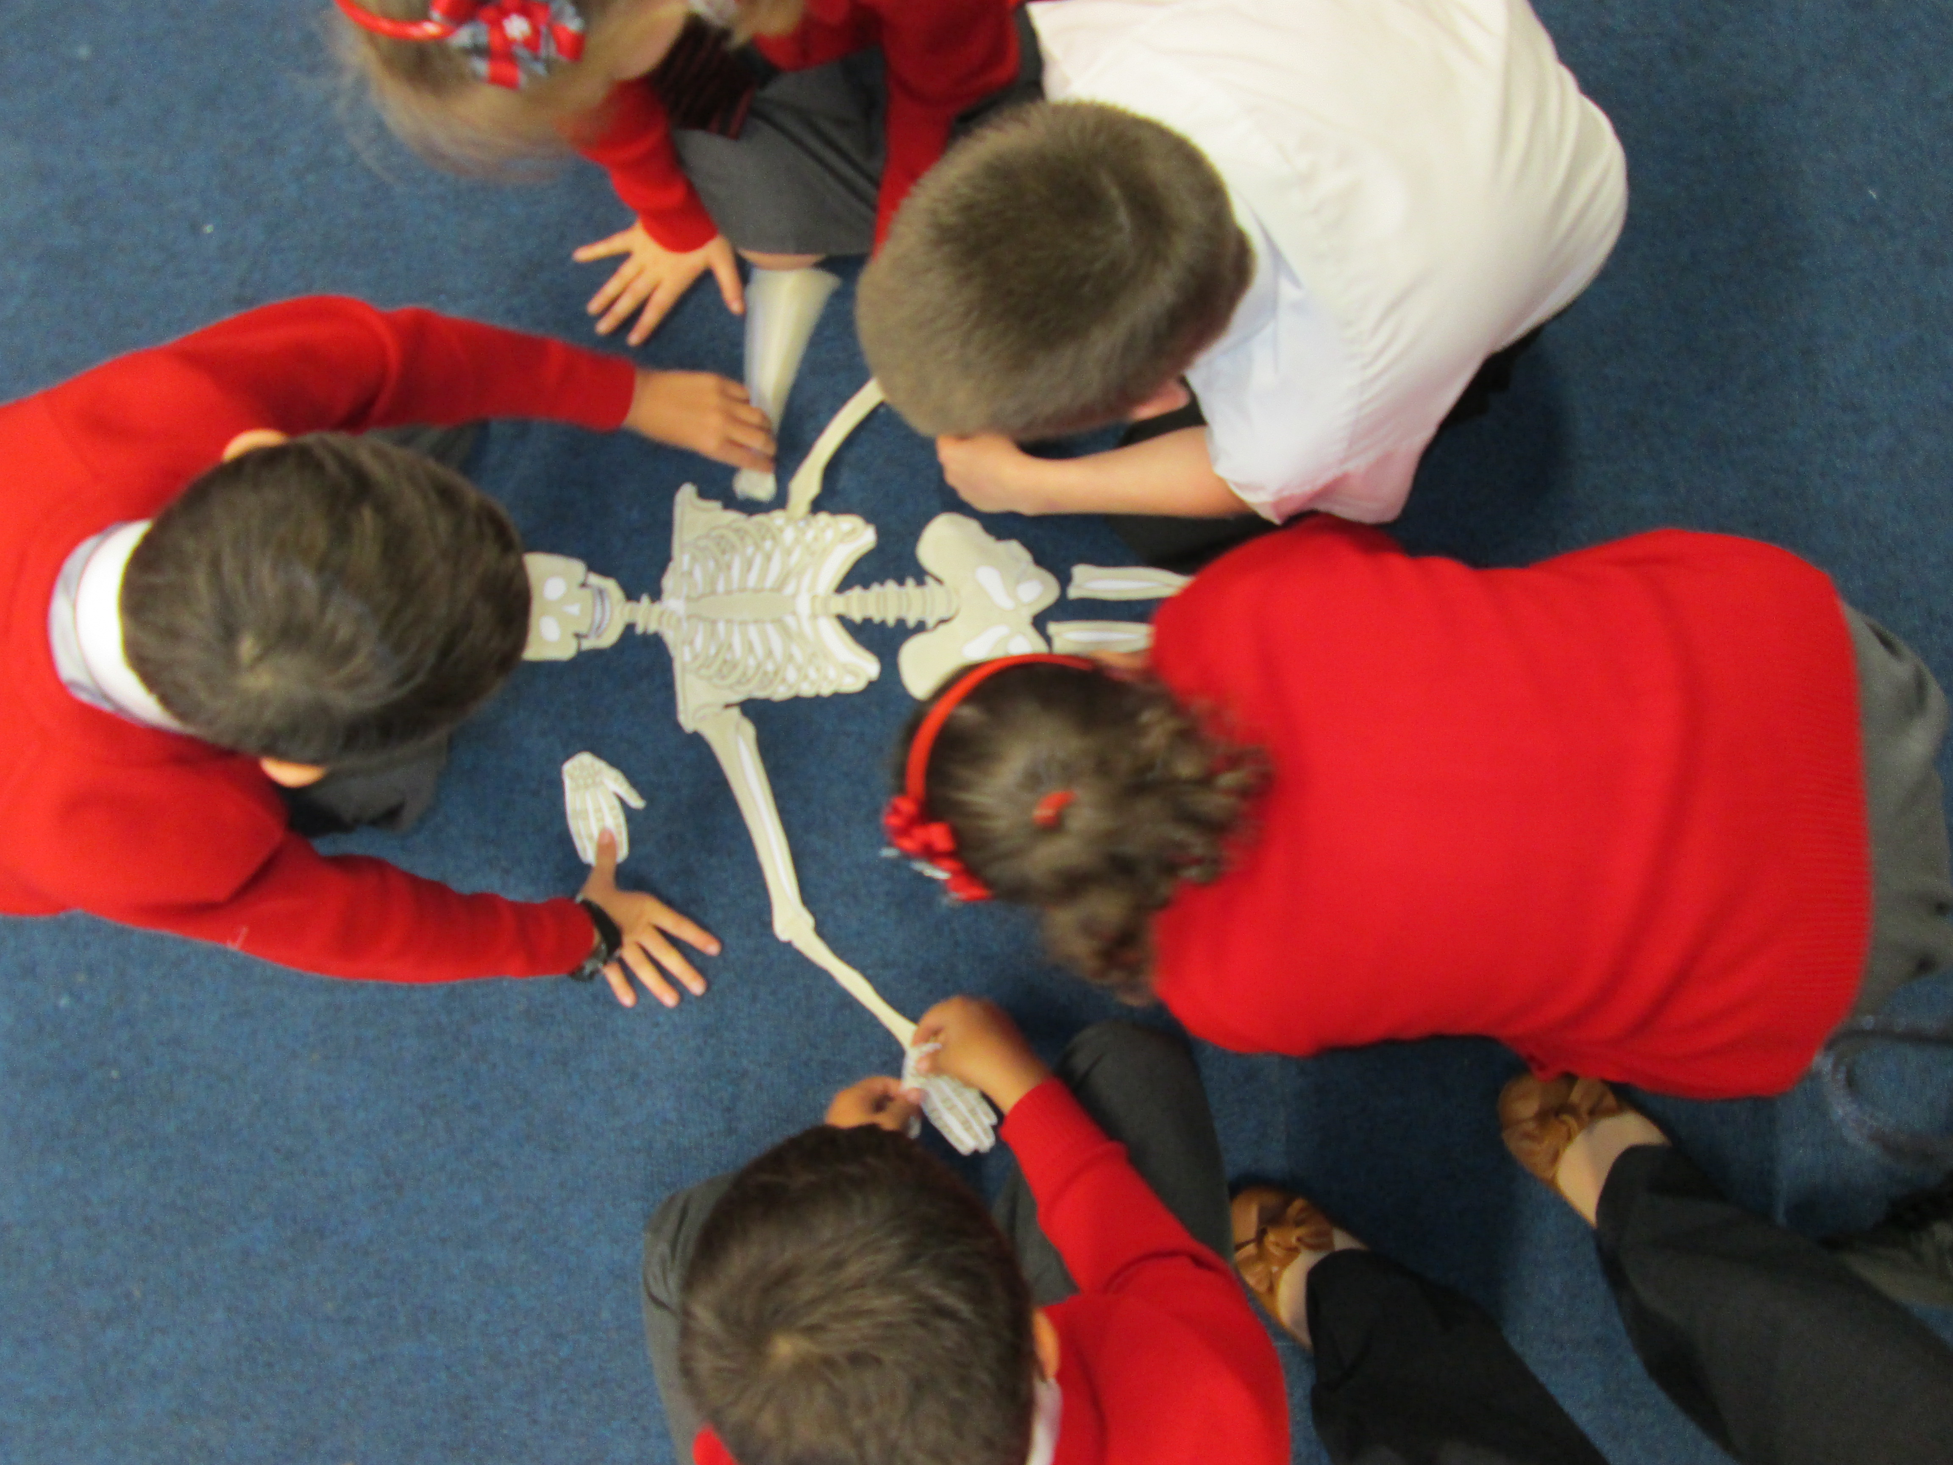

All pupils receive...
- Regular feedback through marking and adult/child interactions.
- Clear guidance about how they need to improve.
- Time to address issues raised in marking.
- Positive and constructive feedback from peers.
- Focussed intervention to overcome periods of slow/stuck progress.

Teaching Assistants will be...
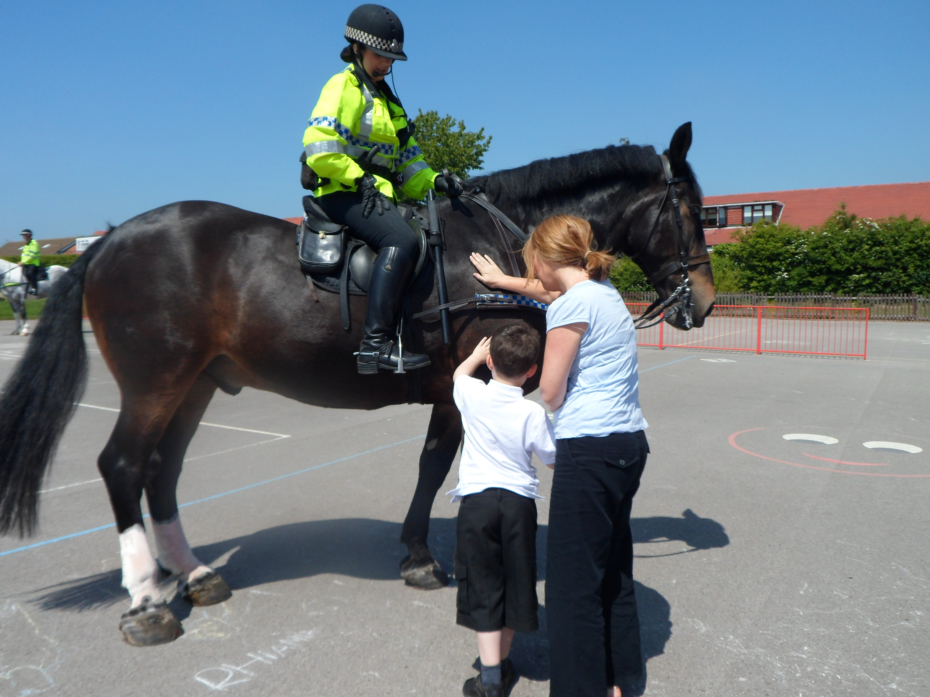
- Effectively and clearly directed to support learning.
- Fully engaged with pupils on the carpet and during lesson times.
- Clear about who they are supporting, with what and why.
- Promoting independence

Learning will be enhanced through...
- The use of ICT in all teaching and learning contexts.
- Consistent classroom management which adheres to the school behaviour policy.
- A bright, well organised learning space.
- The opportunity to experience and develop different learning styles.
- Creative curriculum events which enhance the day to day learning.

