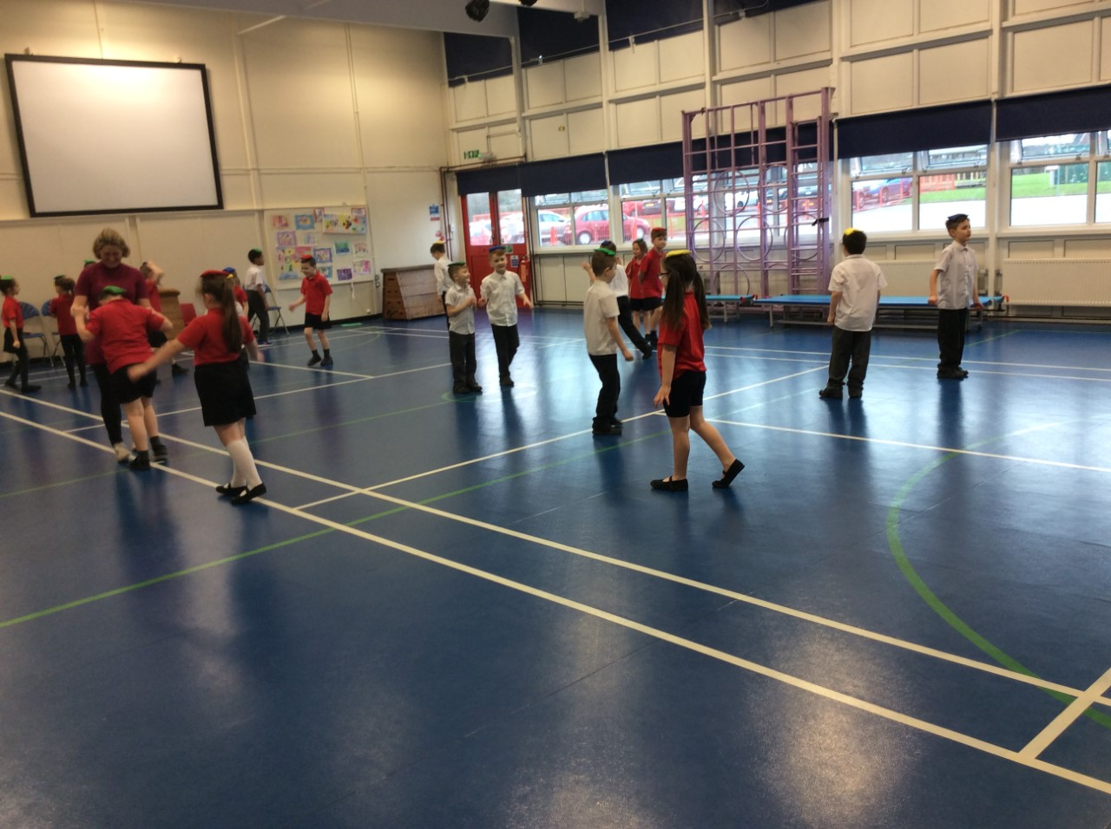

What is the Sports Premium?
PE and Sports Grant
The government is providing additional funding of £150 million per annum for academic years to improve provision of physical education (PE) and sport in primary schools. This funding - provided jointly by the Departments for Education, Health and Culture, Media and Sport – has been allocated to primary school head teachers.
This funding is ring-fenced and therefore can only be spent on provision of PE and sport in schools.

Purpose of funding
Schools must spend the additional funding on improving their provision of PE and sport, but schools have been given the freedom to choose how they do this. A list of possible uses has:
Possible uses for the funding include:
- hiring specialist PE teachers or qualified sports coaches to work alongside primary teachers when teaching PE
- new or additional Change4Life sport club
- paying for professional development opportunities in PE/sport
- providing cover to release primary teachers for professional development in PE/sport
- running sport competitions, or increasing participation in the school games
- buying quality assured professional development modules or materials for PE/sport
- providing places for pupils on after school sport clubs and holiday clubs

Impact of Sports Premium
It is essential for Millbrook to ensure that the funds continue to have a positive impact within school for all students. The tracking and evaluation of impact needs to be a continual process throughout the school year, to maximise the opportunities for the children within school.
AW will be responsible for this as he will have the responsibility for ordering new equipment, booking training courses for staff and organising competitions for the children (both inter and intra competitions). However all teaching staff must work and communicate together to ensure that any money being spent has the desired outcome. If there are any issues or suggestions, staff must inform AW of this as soon as possible in order for any necessary changes to take place.
The training that members of staff have been on has improved the inclusion within P.E lessons, specifically for children with SEND. It has also allowed JD(Literacy lead) to attend an active literacy course which she will implement across the summer term across the school. The funding has been used for supply cover to allow this to happen. This also allowed for the purchase of specific sports equipment for an inclusive SEND focus sport (curling), this would have been impossible without the sports premium.
The decision to employ a sports apprentice has been an impactful use of funding. This has not only provided extra support withing P.E lessons but the support at dinner time with a change 4 life club taking place, help with a variety of afterschool sports clubs and running their own change 4 life club has been a great success this year.
As a school we have focussed on improving the quality of P.E lessons with high quality equipment, with new hockey sticks and goals improving our hockey unit. New speed bounce equipment has impacted the delivery of athletics both within the curriculum and for an afterschool club. 12 brand new footballs for afterschool clubs has increased engagement and the quality of these sessions and has therefore seen numbers of participants grow. A brand new cross country t-shirt has led to an increase in pride of representing schools at competitions and numbers have also increased for clubs. The above mentioned New Age Kurling set a long with a Boccia set has led to an SEND focussed lunchtime sports club being created that has had a great impact, with both confidence and ability of sports for these specific children.
In future, if transport is needed for sports competitions, the sports premium will allow for this.

Millbrook Priorities:
Priority 1- To ensure all children have access to high quality PE teaching and resources.

Priority 2- To identify and implement an assessment process which assesses pupils progress in PE.

Priority 3- Raise the profile of PE across the school.

Priority 4 – To increase our range of extra curricular sporting activities and encourage increased participation in competitive sporting activities for all pupils.

Priority 5 – To further develop the schools healthy active lifestyle initiatives.

At Millbrook we offer a large variety of sports and extracurricular activities. We aim to continue offering all of our children the opportunities to take part in a range of sports at inter, intra and county level. These include:
*Football (boys and girls) * Multi sports (includes hockey, basketball, cricket) *Cross Country
*Indoor Athletics *Outdoor Athletics *Gymnastics *Fencing *Dodgeball *Swimming *Dance *Table Tennis *Cycling
Change4 life – daily sporting opportunities for all Key Stage 2
The Sports Plan for 2017-2018
Sports Grant Received:- £14,359

Total Number of Pupils on roll = 290

Objective:- To effectively use the sports grant to raise the profile and outcomes for children in PE, sport and physical activity across the school

TARGETS AND PRIORITIES | TIMESCALE | RESPONSIBILITY | RESOURCE IMPLICATIONS
Buying into Knowsley School Partnership | October 2017 | HT | £1,250
The profile of PE and sport being raised across the school as a tool for whole school improvement. | By July 2018 | AW and TM (Sport’s Apprentice) | £2000
CPD for Staff in raising confidence in teaching  - Audit current needs  - Facilitate through partnership | By March 2018 | AW and All teachers | Supply costs and training fees £2000
To establish formative and summative assessment procedures for Physical Education in order to secure pupils’ progress  Discussions with PE staff from other schools to take place about them. | Autumn 18 | AW and all staff | Supply cost for AW - £500  Staff meeting time
Increased outdoor physical development resources in Early Years to improve outcomes in physical development | Autumn 17 | EYFS teachers | £2000
Regularly updating PE resources in line with the New Curriculum | November audit and requisition  March order and requisition | AW  AW | £2000
Employing a Sport’s apprentice to support lunchtime and after school sport. | May 2017 – April 2018 | HT with TM | £2132
Employing a local coach to provide weekly after school sport on school site and at the local club on evenings – Will and Phil | Ongoing | AW | £1977
Increased participation in competitive sport. | Ongoing | ALL STAFF | Cost of transport if needed.  Cost of outside teaching for certain sports. £500

