Millbrook Community Primary School

Online Safety Newsletter: April 2018

House Party (Age 9+)

House Party is a video focused social media app. Friends can communicate with each other by joining each other’s ‘house party.’

If your child joins a friend’s party there may be friends of friends also invited so your child could end up speaking to strangers. If parties are not ‘locked’ then anyone can join (though users are alerted if someone they don’t know joins their party).

Daisy Chain App

The Daisy Chain App is an interactive story with game-elements, narrated by Kate Winslet. Children are able to navigate through the story and overcome angry bullies. You could use this app as a family and discuss the different challenges facing Buttercup (the character in the app) with your child.

Why not try the digital sunset challenge?

The aim of the challenge is to encourage children to try for one week, to switch off all phones and other devices like iPads, tablets, computers and gaming consoles at an agreed time each night and to keep the devices out of their bedrooms.

Research shows that by switching off all devices and keeping bedrooms screen-free, three immediate benefits can be gained:

- Better quality sleep. The blue light emitted from screens prevents the release of the sleep hormone melatonin. This is especially so in young, developing brains.
- A much needed break from the demands of social media. Recent studies have shown a strong link between excessive use of social media platforms and anxiety and depression in youngsters. The pressure to be “on” all the time is overwhelming with many children staying up late to ‘like’ posts or reply to comments. The online conversation never stops!
- Less chance of cyber-bullying and sexual exploitation. Making sure that a child is not online and alone in their bedroom at night, cuts down dramatically the opportunity for unwanted contact. Latest figures from the National Crime Agency show an upsurge of 700% in reported online child abuse since 2013 and in the last two years, Childline has seen a 168% rise in calls relating to online bullying and sexual abuse.

More information is available here: https://digitalsunsetchallenge.com/
Instagram (age: 13+)

Instagram is a social networking site owned by Facebook that enables users to share photos and videos. Users are able to upload photos or videos from their mobile devices via an app and these can then be viewed either publically or privately depending on what a user has their profile set to.

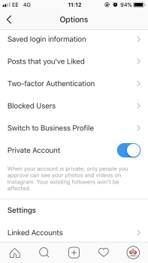
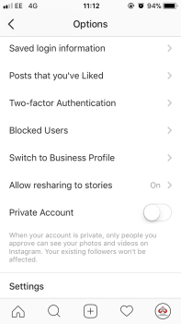
Check your child’s settings
When you sign up to Instagram, by default, anyone can view your profile and posts. If you have a public account then anybody can see and comment on your photos and stories in the Search & Explore tab or hashtag page. We would always recommend a user having a private account so only followers you approve can see your posts.

Other Instagram settings/features

You can filter comments
Instagram filters comments by default but in addition users can also list words, phrases, numbers or emojis that they feel are offensive. Instagram will then hide any comments containing these key words.
- Go to your profile and tap (iOS) or (Android) in the top right
- Tap Comments
- Tap next to Enable Keyword Filters to turn it on

To block someone
- Tap their username to go to their profile
- Tap (iPhone/iPad) or (Android) in the top right
- Tap Block

To report someone or a post
- Tap (iOS) or(Android) above the post/ in the top right of the profile
- Tap Report
- Follow the on-screen instructions

Location tagging

In addition to keeping your profile private we recommend children do not share their location. A user can tag their location when adding a new post so it will show other users where the photo/video was captured (school or home location for example). Talk to your child about the potential consequences of sharing their location.

Searching

“45% of young people reported seeing violence and hatred on Instagram. 39% reported sexual content.” https://www.net-aware.org.uk

Instagram has a search tab where users can search and view popular content posted by millions of other users from all over the world. Although Instagram does not allow nudity and removes any content that violates their guidelines once they’re aware of it, there is still the possibility your child may see inappropriate content. It’s really important to talk to your child regularly and make sure that they know that you’re always there to talk to if they have any concerns.

