**Millbrook Community Primary School**



Online Safety Newsletter: June 2018



**YouTube Kids App**

YouTube Kids was created to make it safer and simpler for kids to explore YouTube and includes a number of parental controls to tailor the experience. The app uses a mix of filters, user feedback and human reviewers to keep the videos in YouTube Kids family friendly. *But no system is perfect and inappropriate videos can slip through.*  
Here are the control features available within the app:

* **Search Control:** Ability to turn search on or off.
* **Timer:** Set up a timer to put limits on how long your kids can play with the app.
* **Watch History:** Keep up with what your kids are watching.
* **Video Reporting:** immediately report videos that shouldn’t be in the app.

*YouTube Kids contains paid ads in order to offer the app for free. Your kid may also see videos with commercial content from YouTube creators that are not paid ads.*

### YouTube (age: 13+)

### For the first time ever, Kids Insights have found that all children between the age of 4 and 18 have watched more Netflix and YouTube than normal TV. For the first time, even the youngest children aged 4-6 have watched more streaming platforms than regular TV. *(Source:* [*http://www.kidsinsights.co.uk/new-data-just-in/*](http://www.kidsinsights.co.uk/new-data-just-in/)*)*

### Safety controls

Set up a shared family account on YouTube so that you can log in and see a history of what videos have been watched and search history. By having an account, you can also turn the Restricted Mode on and lock it. Restricted mode hides videos that may contain inappropriate content (although no filter is 100% accurate).

To lock the restricted mode, you will need a Google account. To create a free Google account, go to google.com and click Sign In in the top right hand corner. You will then see the option to create a new account. Once you have done this, go back to YouTube and scroll down to the bottom of the page and change the Restricted Mode to on and click save. Then **log out** of your Google account so another user cannot deactivate the restricted mode (you would have to log back in to your Google account to unlock the restricted mode). You must follow these steps on every browser you have on your computer e.g. Chrome, Internet Explorer and also if you have a separate YouTube app on a tablet/phone.

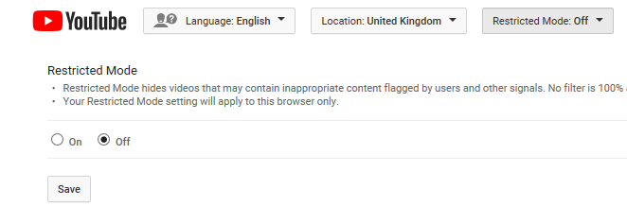

**Log back into your Google account on a regular basis to view the history so you can see what your child has been watching and searching for.**

**“The most popular platforms 8-17s are using to chat to their friends on a daily basis are YouTube (41%), WhatsApp (32%), Snapchat (29%), Instagram (27%) and Facebook or Facebook Messenger (26%).”**

**Source** https://www.saferinternet.org.uk/digital-friendships

* **Subscribe to family friendly YouTube channels**

**What is a Vlogger?**

Vlog – is short for ‘video blog’. A Vlogger is someone who produces these videos and shares them on a video sharing platform. These videos are normally of a personal interest to the Vlogger.

There is no restriction as to who can become a Vlogger, all you need is an account with a video sharing platform, a topic or interest to Vlog about and a device with a camera on it.

They are extremely popular with children. Vloggers are perceived to be a more authentic voice, not edited in the way that many TV programmes are.

* Talk to your child about what they would like to watch on YouTube and subscribe to channels together. By subscribing to channels, you will be creating a safer feed.

**How to report a video**

Click on the three dots under the video and select ‘report.’

## 

**YouTubing tips from Internet Matters**

(Source: <https://www.internetmatters.org/hub/guidance/youtube-tips-and-tricks-to-keep-your-children-entertained-and-safe/> )

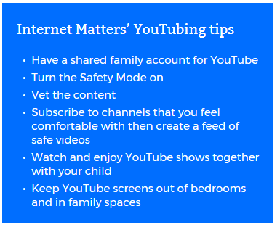

**“Young people want support from the adults in their lives: Over three-quarters (77%) of respondents aged 8-17 years said that they wanted their parents and carers to be there for them if something worried them online.”**

***Source*** *https://www.saferinternet.org.uk/digital-friendships*