Millbrook Community Primary School
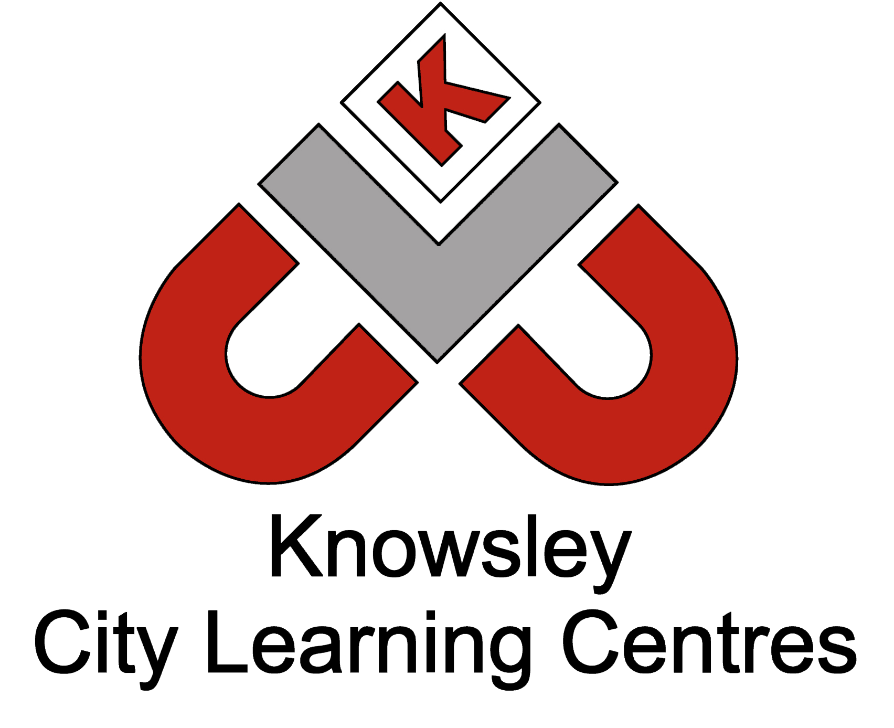

Online Safety Newsletter: March 2018

We recommend that you have regular chats with your child about what they are doing online and talk to your child about what apps they are using. Make sure your child:
Apps to try

For 3-7 years:
Digiduck

Available on both the App
Store and Google Play. Internet Matters along with Childnet have created a storybook app that parents and children can read together.

The story helps parents start a conversation and teach children how to be a good friend online.

For 8 – 10 years: Internet Matters’: E-safety app

Available on both the App Store and Google Play. This app was created by ‘Internet Matters’ to help parents talk about online safety issues with their children.

The app contains a number of quizzes and games to encourage parents and children to talk about different online safety subjects.

- Understands not to share their full name, contact details or address.
- Is aware of how much information that they can give away without realising e.g. by wearing a school uniform in a photo/video identifies what school they attend.
- Understands how easy it is for someone to screenshot messages/photos so even when they think they’re having a private conversation it could be shared with other people.
- Knows how to report and block users on any websites/apps that they use.

Further advice:

NSPCC and O2 have a free online safety helpline for parents/carers - 0808 8005002.

We’ve listed two apps opposite which aim to encourage parents and children to talk about online safety which you may find useful to start a conversation.

This website also contains useful advice: https://www.anti-bullyingalliance.org.uk/tools-information/advice-parents/im-worried-about-cyberbullying

NSPCC and O2 Net Aware newsletter
The NSPCC and O2 produce a Net Aware newsletter which includes information about new social networks, apps and games and how to keep your child safe online. Use this link to sign up to their newsletter: https://www.net-aware.org.uk/

Gun free action apps
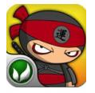
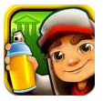

Subway Surfers (9+) Chop Chop Ninja (10+) Clay Jam (5+) Cordy (8+) The 7D Mine Train (8+)

