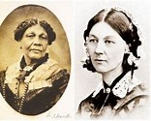
History Research Project
Each class in the school have been set a History Research Project.
Our topic in the Summer Term would have been the Victorians. To link in with this - and with our fantastic NHS nurses - I have chosen two people to be researched.
They are:
- Mary Seacole
- Florence Nightingale
You can research either one - or both! Can you found out why we still remember them? How did they contribute to society?
Your project can take any form. It could be:
- A fact file
- Pictures - drawings, collages etc.
- A PowerPoint
- Drama (short film or presentation)
Here is a link to get you started (got to love a bit of Horrible Histories!).
Florence Nightingale v Mary Seacole
Upload and share any work to Twitter. Can’t wait to see it!

