Name: ___________________
Class 10
Home Learning Pack
June 2020
Date: ___________________

Any questions you have about the work message Mr Webster on Class dojo. Any older siblings at home will be able to help, use them!

Maths
Complete the following activities about mixed numbers and fractions (we covered this before lockdown). Remember, before adding or subtracting fractions they must have the same DENOMINATOR (BOTTOM NUMBER).

Adding decimals is the next step, it can seem daunting but a lot of the principles from adding normal numbers together is the same and children usually understand this quickly. This lesson from youtube may help as a starting point. https://www.youtube.com/watch?v=JbGdrXW1z7U.
Remember 1 tenth is 0.1 and 1 hundredth is 0.01.

English
Complete the following grammar and writing activities.

Read the first extract from The Worst Witch by yourself.
Top tip!
If you struggle with any words, try the following reading strategies.
- Sound the word out. Can you split the word up and then try to say it?
- Think about whether it looks like another word that you know.
- Miss the word out and read ahead. Then go back and ‘guess’ what the word may have been.
Extract 1
There were so many rules that you couldn’t do anything without being told off and there seemed to be tests and exams every week.
Mildred Hubble was in her first year at the school. She was one of those people who always seem to be in trouble. She didn’t exactly mean to break rules and annoy the teachers, but things just seemed to happen whenever she was around. You could rely on Mildred to leave her hat on back-to-front or her bootlaces trailing along the floor. She couldn’t walk from one end of a corridor to the other without someone yelling at her, and nearly every night she was writing lines or being kept in (not that there was anywhere to go if you were allowed out). Anyway, she had lots of friends, even if they did keep their distance in the potion laboratory, and her best friend Maud stayed loyally by her through everything, however hair-raising. They made a funny pair, for Mildred was tall and thin with long plaits which she often chewed absent-mindedly (another thing she was told off about), while Maud was short and tubby, had round glasses and wore her hair in bunches.
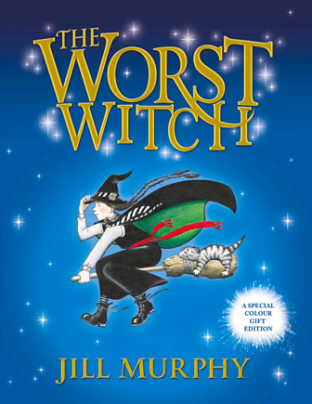
Writers choose their words carefully so that readers can really get to know the characters.
Think about how Jill Murphy has added extra information about her characters, then have a look at some of the quotes in the table below.
Explain what they tell us about the characters or the plot.
You can copy out the table and fill in your answers, or say your answers out loud.
Top tip
You could use these sentence starters to help you.
This tells us that...
This shows us that...
Quote | What Does This Tell You?
There were so many rules that you couldn’t do anything without being told off... | This tells us that no matter how well-behaved the pupils were, they would probably still get in trouble because there were so many rules.
... but things just seemed to happen whenever she was around.
... not that there was anywhere to go if you were allowed out.
... even if they did keep their distance in the potion laboratory...
... with long plaits which she often chewed absent-mindedly...
Writing
Try some of these great writing ideas on bbc bitesize.
https://www.bbc.co.uk/bitesize/articles/zrgq2sg
https://www.bbc.co.uk/bitesize/articles/zrb48xs
These will help you to write a recount of time during lockdown and research our humanities topics to produce reports.

Science
Watch this short clip and complete the worksheet.
https://www.bbc.co.uk/bitesize/articles/z6xckmn

Read the following page on bitesize and complete the activity, use a fridge magnet to test the different items found at home.
https://www.bbc.co.uk/bitesize/articles/zftckmn

Humanities
In History this term we would have been studying the importance of the slave trade to British history, with a particular focus on Liverpool. We had a great trip planned to the International Slavery Museum in Liverpool. If your child would research this and produce either a poster or write a long piece of writing about this topic that would be great. For research projects like this I would suggest starting with the 5w’s. Who? What? Where? When? Why? Any work completed send over as an attachment to Mr Webster.

Art
Any Art projects completed send a pic to Mr Webster.
PE
We know how important exercise is to keep the body and mind happy. Aim for 30 minutes activity each day, park walks have now been encouraged with other members of the household. Fingers crossed the weather is nice!

