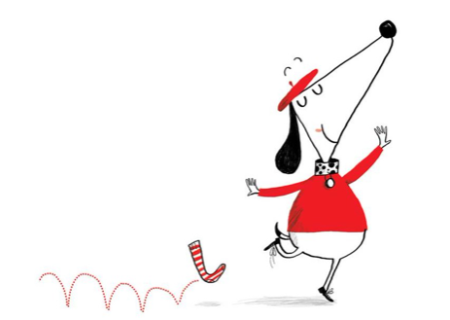

Write expanded noun phrases to describe Claude.