All About Me!
II
My favourite colour… My name is… On TV I like to watch…

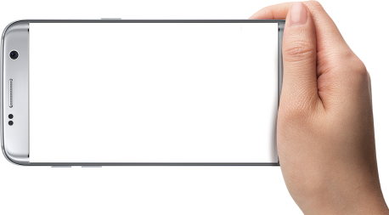
I am ________ years old.

Things I love…

Things I don’t like…

My best book … My favourite subject…
Take a selfie…

