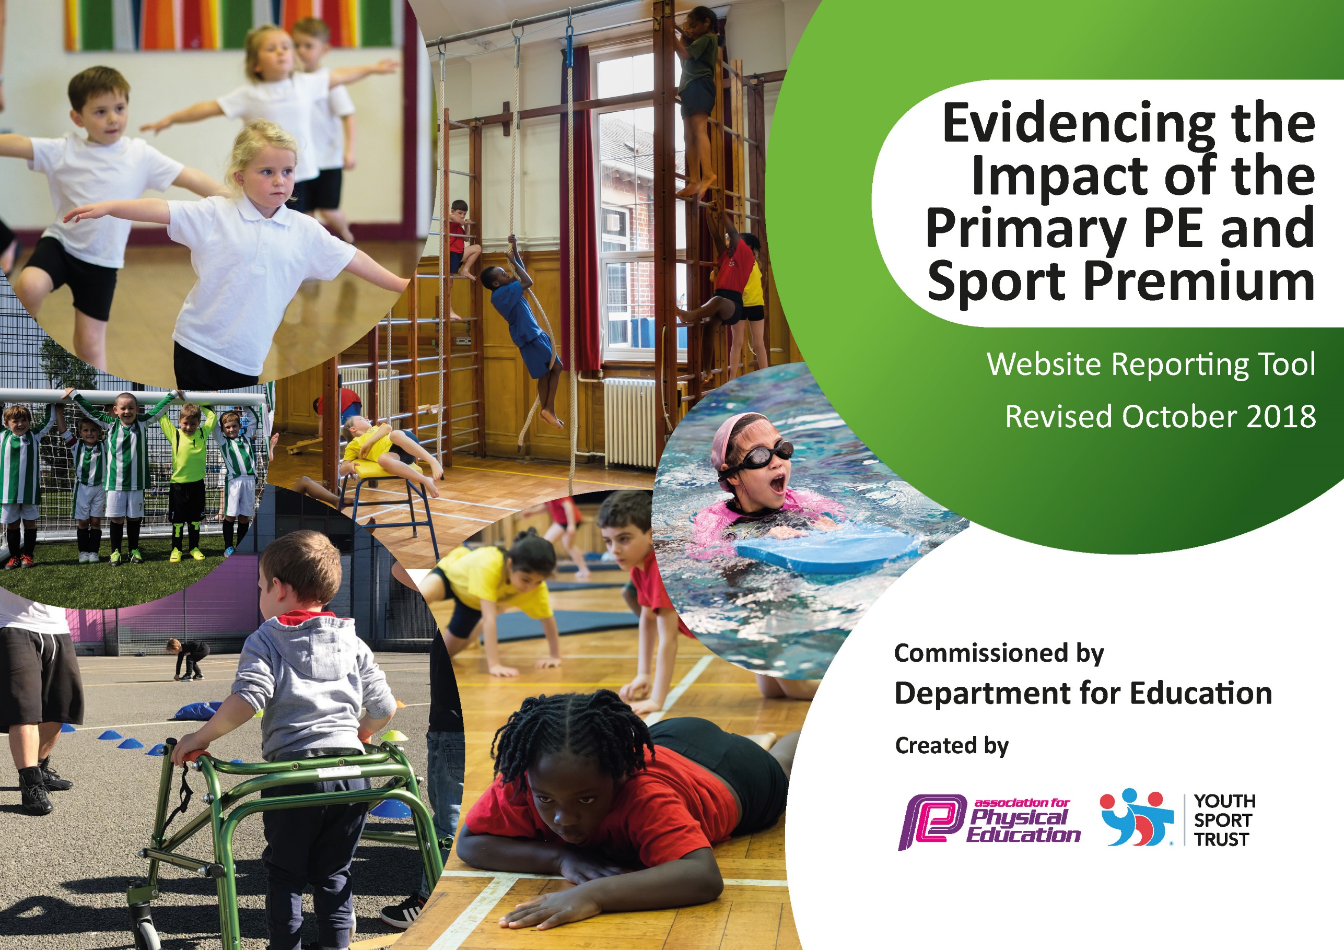
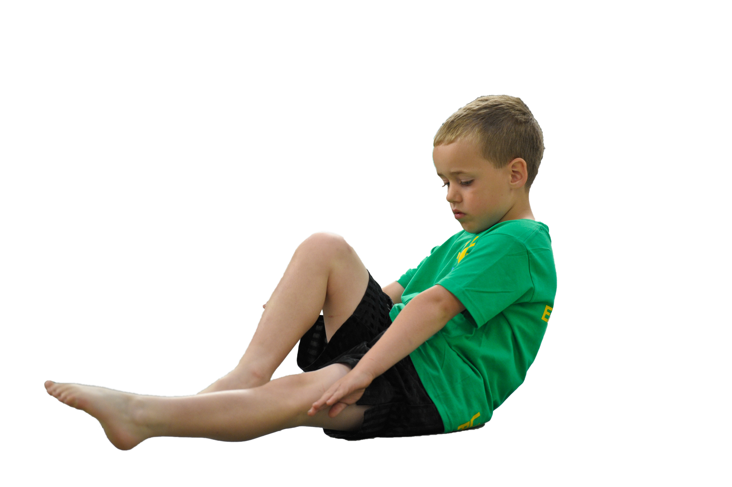
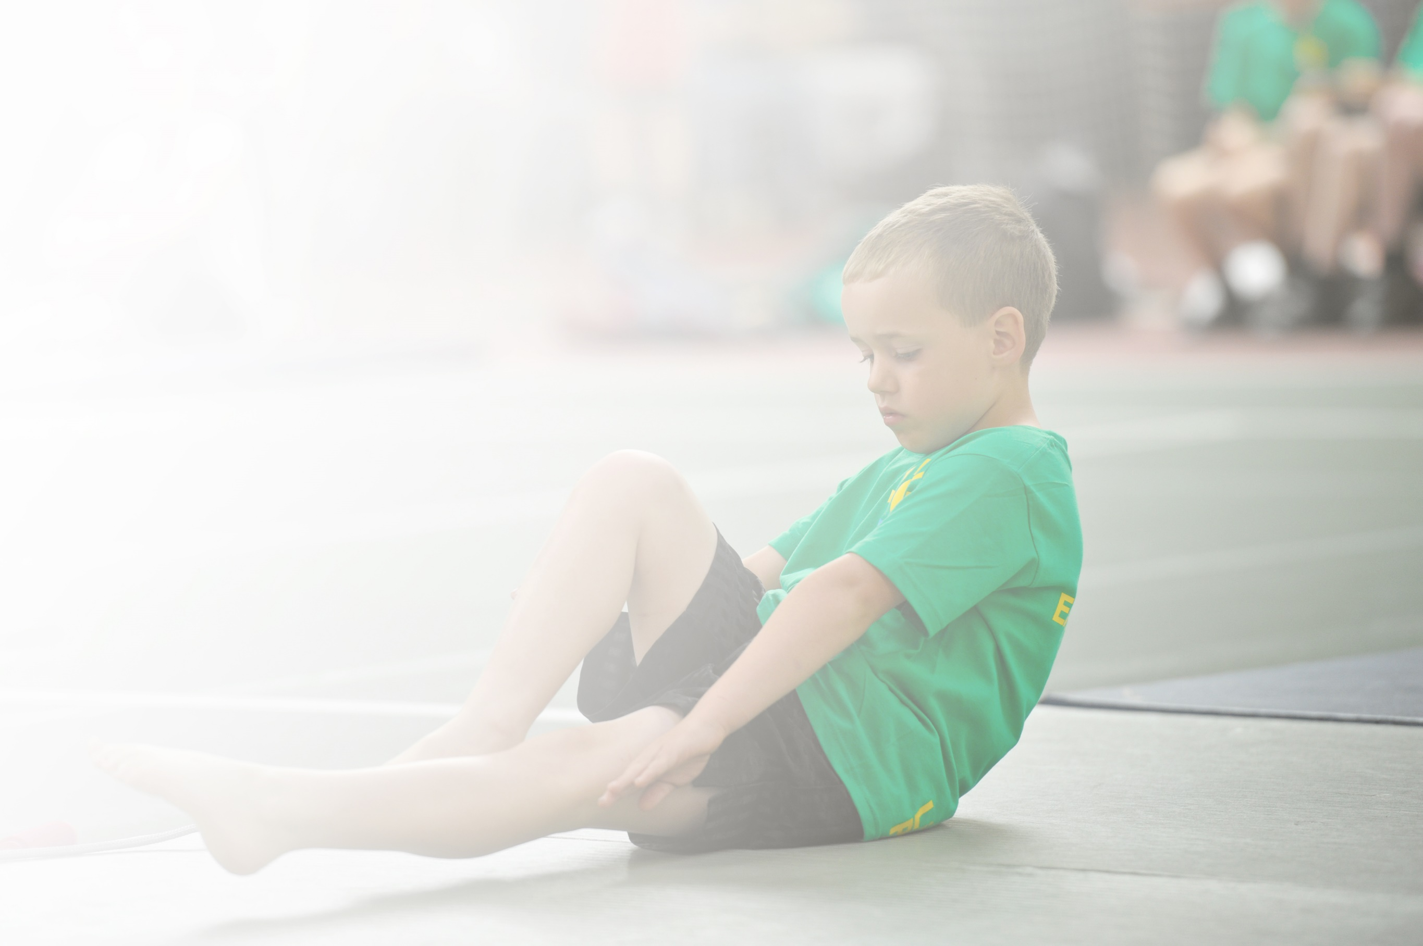
Schools must use the funding to make additional and sustainable improvements to the quality of Physical Education, Sport and Physical Activity (PESPA) they offer. This means that you should use the Primary PE and Sport Premium to:

- Develop or add to the PESPA activities that your school already offer
- Build capacity and capability within the school to ensure that improvements made now will benefit pupils joining the school in future years

Please visit gov.uk for the revised DfE guidance including the 5 key indicators across which schools should demonstrate an improvement. This document will help you to review your provision and to report
your spend. DfE encourages schools to use this template as an effective way of meeting the reporting requirements of the Primary PE and Sport Premium.

We recommend you start by reflecting on the impact of current provision and reviewing the previous
spend. Under the Ofsted Schools Inspection Framework, inspectors will assess how effectively leaders use the Primary PE and Sport Premium and measure its impact on outcomes for pupils, and how effectively governors hold them to account for this.

Schools are required to publish details of how they spend this funding as well as on the impact it has on pupils’ PE and sport participation and attainment by the end of the summer term or by 31 July 2019 at the
latest.
We recommend regularly updating the table and publishing it
on your website throughout the year, as evidence of your
ongoing review into how you are using the money to
secure maximum, sustainable impact. To see an
example of how to complete the table please
click HERE.

Support for review and reflection - considering the 5 key indicators from DfE, what development needs are a priority for your setting and your students now and why? Use the space below to reflect on previous spend, identify current need and priorities for the future.

Key achievements to date: | Areas for further improvement and baseline evidence of need:
Bronze school games mark achieved.  Children have attended many sporting events.  Equipment used in school is safe and effective.  Training opportunities have been attended and information given back to wider staff.  PE apprentice has been successful.  Afterschool clubs are well attended. | Percentage of year 6 swimmers could improve.  More structured activity during the school day to achieve Gold school games mark.  Refresh old equipment with new, ensuring that it is stored safely and securely to allow equipment to be used for years.

Meeting national curriculum requirements for swimming and water safety | Please complete all of the below:
What percentage of your current Year 6 cohort swim competently, confidently and proficiently over a distance of at least 25 metres?  N.B. Even though your children may swim in another year please report on their attainment on leaving  primary school. | 78%  24/31
What percentage of your current Year 6 cohort use a range of strokes effectively [for example, front crawl, backstroke and breaststroke]? | 78%
What percentage of your current Year 6 cohort perform safe self-rescue in different water-based situations? | 78%
Schools can choose to use the Primary PE and Sport Premium to provide additional provision for swimming but this must be for activity over and above the national curriculum requirements. Have you used it in this way? | No

Action Plan and Budget Tracking
Capture your intended annual spend against the 5 key indicators. Clarify the success criteria and evidence of impact that you intend to measure to evaluate for students today and for the future.

Academic Year: 2018/19 | Total fund allocated: £ | Date Updated:
Key indicator 1: The engagement of all pupils in regular physical activity – Chief Medical Officer guidelines recommend that primary school children undertake at least 30 minutes of physical activity a day in school |  |  |  | Percentage of total allocation:
 |  |  |  | %
School focus with clarity on intended impact on pupils: | Actions to achieve: | Funding allocated: | Evidence and impact: | Sustainability and suggested next steps:
Buying into KSSP, children will have access to competition across Kirkby and Knowsley with a variety of sports.  PE Passport app to be used across school as planning for the curriculum.  PE planning website accessible as secondary source of PE plans if needed. | KSSP with liaise with AW throughout the year, indicating the sporting competition opportunities available to Knowsley schools.  IT technician to ensure that the app is updated regularly across all teaching ipads. | £1550  £539  £120 | The children have competed in many competitions throughout the year such as football, swimming, kurling and dodgeball.  PE teaching across the school has improved, the children are more engaged in lessons and are more active. | Millbrook will buy into KSSP again next year, we will attempt to enter more competitions throughout the year.  Millbrook will continue to use the app in 2019/20.
Key indicator 2: The profile of PESSPA being raised across the school as a tool for whole school improvement |  |  |  | Percentage of total allocation:
 |  |  |  | %
School focus with clarity on intended impact on pupils: | Actions to achieve: | Funding allocated: | Evidence and impact: | Sustainability and suggested next steps:
Funky feet music resources in nursery.  PE apprentice employed to support PE lessons, lunchtime clubs and afterschool.  Shed bought as storage for new pe equipment. | Funky feet music sessions for nursery children, giving a more structured approach to sessions.  Level of activity will increase in PE lessons and have more structure at playtimes with the guidance of an adult.  Shed assembled by site manager to store new equipment. | £70  £2466.75  £437.49 | Children enjoyed resources and having more structure to music.  Staff are supported to deliver PE sessions, ensuring child engagement throughout lessons.  New equipment is safe and will be usable for years. | Resource will be used again next year.  PE apprenticeship has now finished.  All future PE equipment will be stored away from children to ensure it is usable for a long time.

Key indicator 3: Increased confidence, knowledge and skills of all staff in teaching PE and sport |  |  |  | Percentage of total allocation:
 |  |  |  | %
School focus with clarity on intended  impact on pupils: | Actions to achieve: | Funding  allocated: | Evidence and impact: | Sustainability and suggested  next steps:
CPD for staff training,  AW has been trained in active literacy. This has been taught in classes 7, 9 & 10 as a replacement for 1 guided reading session a week.  AW has completed FA primary teacher award.  FA Active Play Through Storytelling course completed by KS1 staff. | AW has rolled out an active literacy programme across KS2, this has been well received by pupils and staff.  AW more equipped to complete learning walks and feedback excellent practice to staff.  Approaching story telling in KS1 in a more active way. | £200 | Active literacy session engaged learners very quickly. In year 3 the focus was improving use of adjectives, this improvement was clear after a few sessions.  AW can give more constructive feedback to sessions, especially invasion games.  More active approach now to story telling in KS1. | AW has booked a staff meeting with PE passport. This will ensure that all teachers including 2 NQTs will be equipped and ready to teach the curriculum.  Active literacy to be continued across KS2.
Key indicator 4: Broader experience of a range of sports and activities offered to all pupils |  |  |  | Percentage of total allocation:
 |  |  |  | %
School focus with clarity on intended  impact on pupils: | Actions to achieve: | Funding  allocated: | Evidence and impact: | Sustainability and suggested  next steps:
TA employed to run afterschool sports clubs including change 4 life, 5 days a week.  Dance afterschool club KS1 &2  Multisport ks1&2.  Regularly updating PE resources. | Children offered places to attend a variety of clubs at no cost afterschool.  AW to order new equipment throughout the year. | £1940  £1440 per term  £4320  £2000 | Level of engagement in afterschool clubs has been much better this year. School staff have also ran afterschool clubs for no cost to increase engagement across school.  New equipment led to a more successful sports day. Safer PE lessons with correct equipment used. | Dance will continue next year. TA will continue to be employed to run 5 afterschool clubs a week. All staff will be obliged to run 8 weeks of afterschool club, most are sport based.
Key indicator 5: Increased participation in competitive sport |  |  |  | Percentage of total allocation:
 |  |  |  | %
School focus with clarity on intended  impact on pupils: | Actions to achieve: | Funding  allocated: | Evidence and impact: | Sustainability and suggested  next steps:
KSSP registration.  Donation to highschool for bus.  Staff driving. | See above  Links to local high school should remain strong.  All insured staff volunteer to ensure children can attend sporting events. | £50  £0 | SEN children could attend kurling competition.  Children have represented school throughout the year. | Hopefully we will have the chance next year to utilise the bus again.

