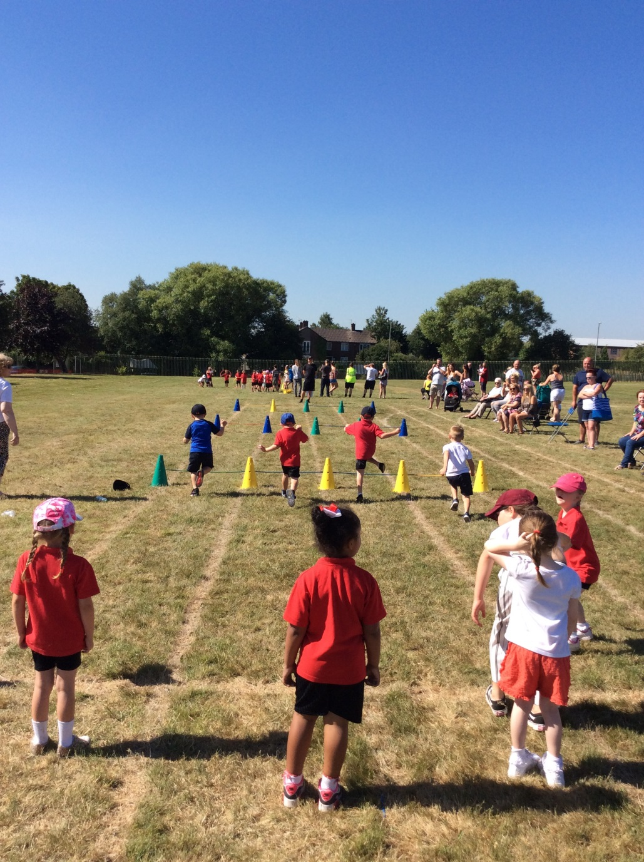
Millbrook’s Sports Premium Action Plan 2019-20
What is the Sports Premium?
PE and Sports Grant
The government is providing additional funding of £150 million per annum for academic years to improve provision of physical education (PE) and sport in primary schools. This funding - provided jointly by the Departments for Education, Health and Culture, Media and Sport – has been allocated to primary school head teachers.
This funding is ring-fenced and therefore can only be spent on provision of PE and sport in schools.

Purpose of funding
Schools must spend the additional funding on improving their provision of PE and sport, but schools have been given the freedom to choose how they do this. A list of possible uses has:
Possible uses for the funding include:
- hiring specialist PE teachers or qualified sports coaches to work alongside primary teachers when teaching PE
- new or additional Change4Life sport club
- paying for professional development opportunities in PE/sport
- providing cover to release primary teachers for professional development in PE/sport
- running sport competitions, or increasing participation in the school games
- buying quality assured professional development modules or materials for PE/sport
- providing places for pupils on after school sport clubs and holiday clubs

Millbrook Priorities:
Priority 1- To ensure all children have access to high quality PE teaching and resources.

Priority 2- To identify and implement an assessment process which assesses pupils progress in PE.

Priority 3- Raise the profile of PE across the school.

Priority 4 – To increase our range of extra curricular sporting activities and encourage increased participation in competitive sporting activities for all pupils.

Priority 5 – To further develop the schools healthy active lifestyle initiatives.

At Millbrook we offer a large variety of sports and extracurricular activities. We aim to continue offering all of our children the opportunities to take part in a range of sports at inter, intra and county level. These include:
*Football (boys and girls) * Multi sports (includes hockey, basketball, cricket) *Cross Country
*Indoor Athletics *Outdoor Athletics *Gymnastics *Fencing *Dodgeball *Swimming *Dance *Cycling
Change4 life – daily sporting opportunities for all Key Stage 2

The Sports Plan for 2019-2020
Sports Grant Received:- £18,000

Total Number of Pupils on roll = 265 (excluding nursery)

Objective:- To effectively use the sports grant to raise the profile and outcomes for children in PE, sport and physical activity across the school

TARGETS AND PRIORITIES | TIMESCALE | RESPONSIBILITY | RESOURCE IMPLICATIONS
P1 P4 P5  Buying into Knowsley School Sports Partnership. SLA Level 2 for school. | October 2019 | HT | £1250
P 1 & 2  PE Passport app used across KS1 and KS2.  PE planning website used as secondary resource for PE lessons. | Training booked for September 2019, ensuring all current and new staff can use app effectively for planning PE and assessing progress. | PE lead | £599  £129
P1 P3  Teaching assistant employed in afternoons to focus specifically on sport. They will lead small groups of disengaged/unfit children in focussed PE lessons ensuring they can access the curriculum at their level and increase participation in these sessions. | From September ‘19 | HT & PE lead | £8000 per year
P 4  Teaching assistant will be employed for an hour after school each day to run 5 afterschool clubs. These will cover a range of sports.  All teaching staff will be obliged to run 8 weeks of afterschool clubs for an hour with a focus on PE. | From September ‘19 | HT & PE lead
P4  Due to current contract the teaching assistant will have significant payback hours (48). These will be used to run 2 morning clubs and a lunchtime club throughout the week. | From September ‘19 | HT & PE lead
P4  CV Dance to continue afterschool club throughout the year. | From September ’19 throughout year. | Pe lead | 32 weeks  £1,120
P3  School to have a bank of PE kits/pumps to ensure participation across school. | October ‘19 | PE lead & Business manager | £3000 max
P1  Revamp of PE equipment throughout year.  Waterproof clothing bought for residentials. | October 19 Audit and Order.  April ’20 Final order. | PE lead
P3  CPD opportunities for all staff throughout the year, focus on NQT. | October ’19 booking | PE lead | £300
P3 P4 P5  Transport/Supply cover allocated to ensure participation in sporting opportunities for children throughout the year. | October ’19-July 20. | PE lead & Business manager | £500

Remainder of funding to be allocated throughout the year and added to plan as and when it is required.7
For example Lord derby estate visit.
Year 6 swimming.

