NATIONAL BREAKFAST PROGRAMME
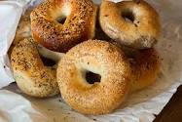

FREE BAGELS ARE AVAILABLE
FROM 8:40AM
EACH DAY
AT OUR SCHOOL GATES.

