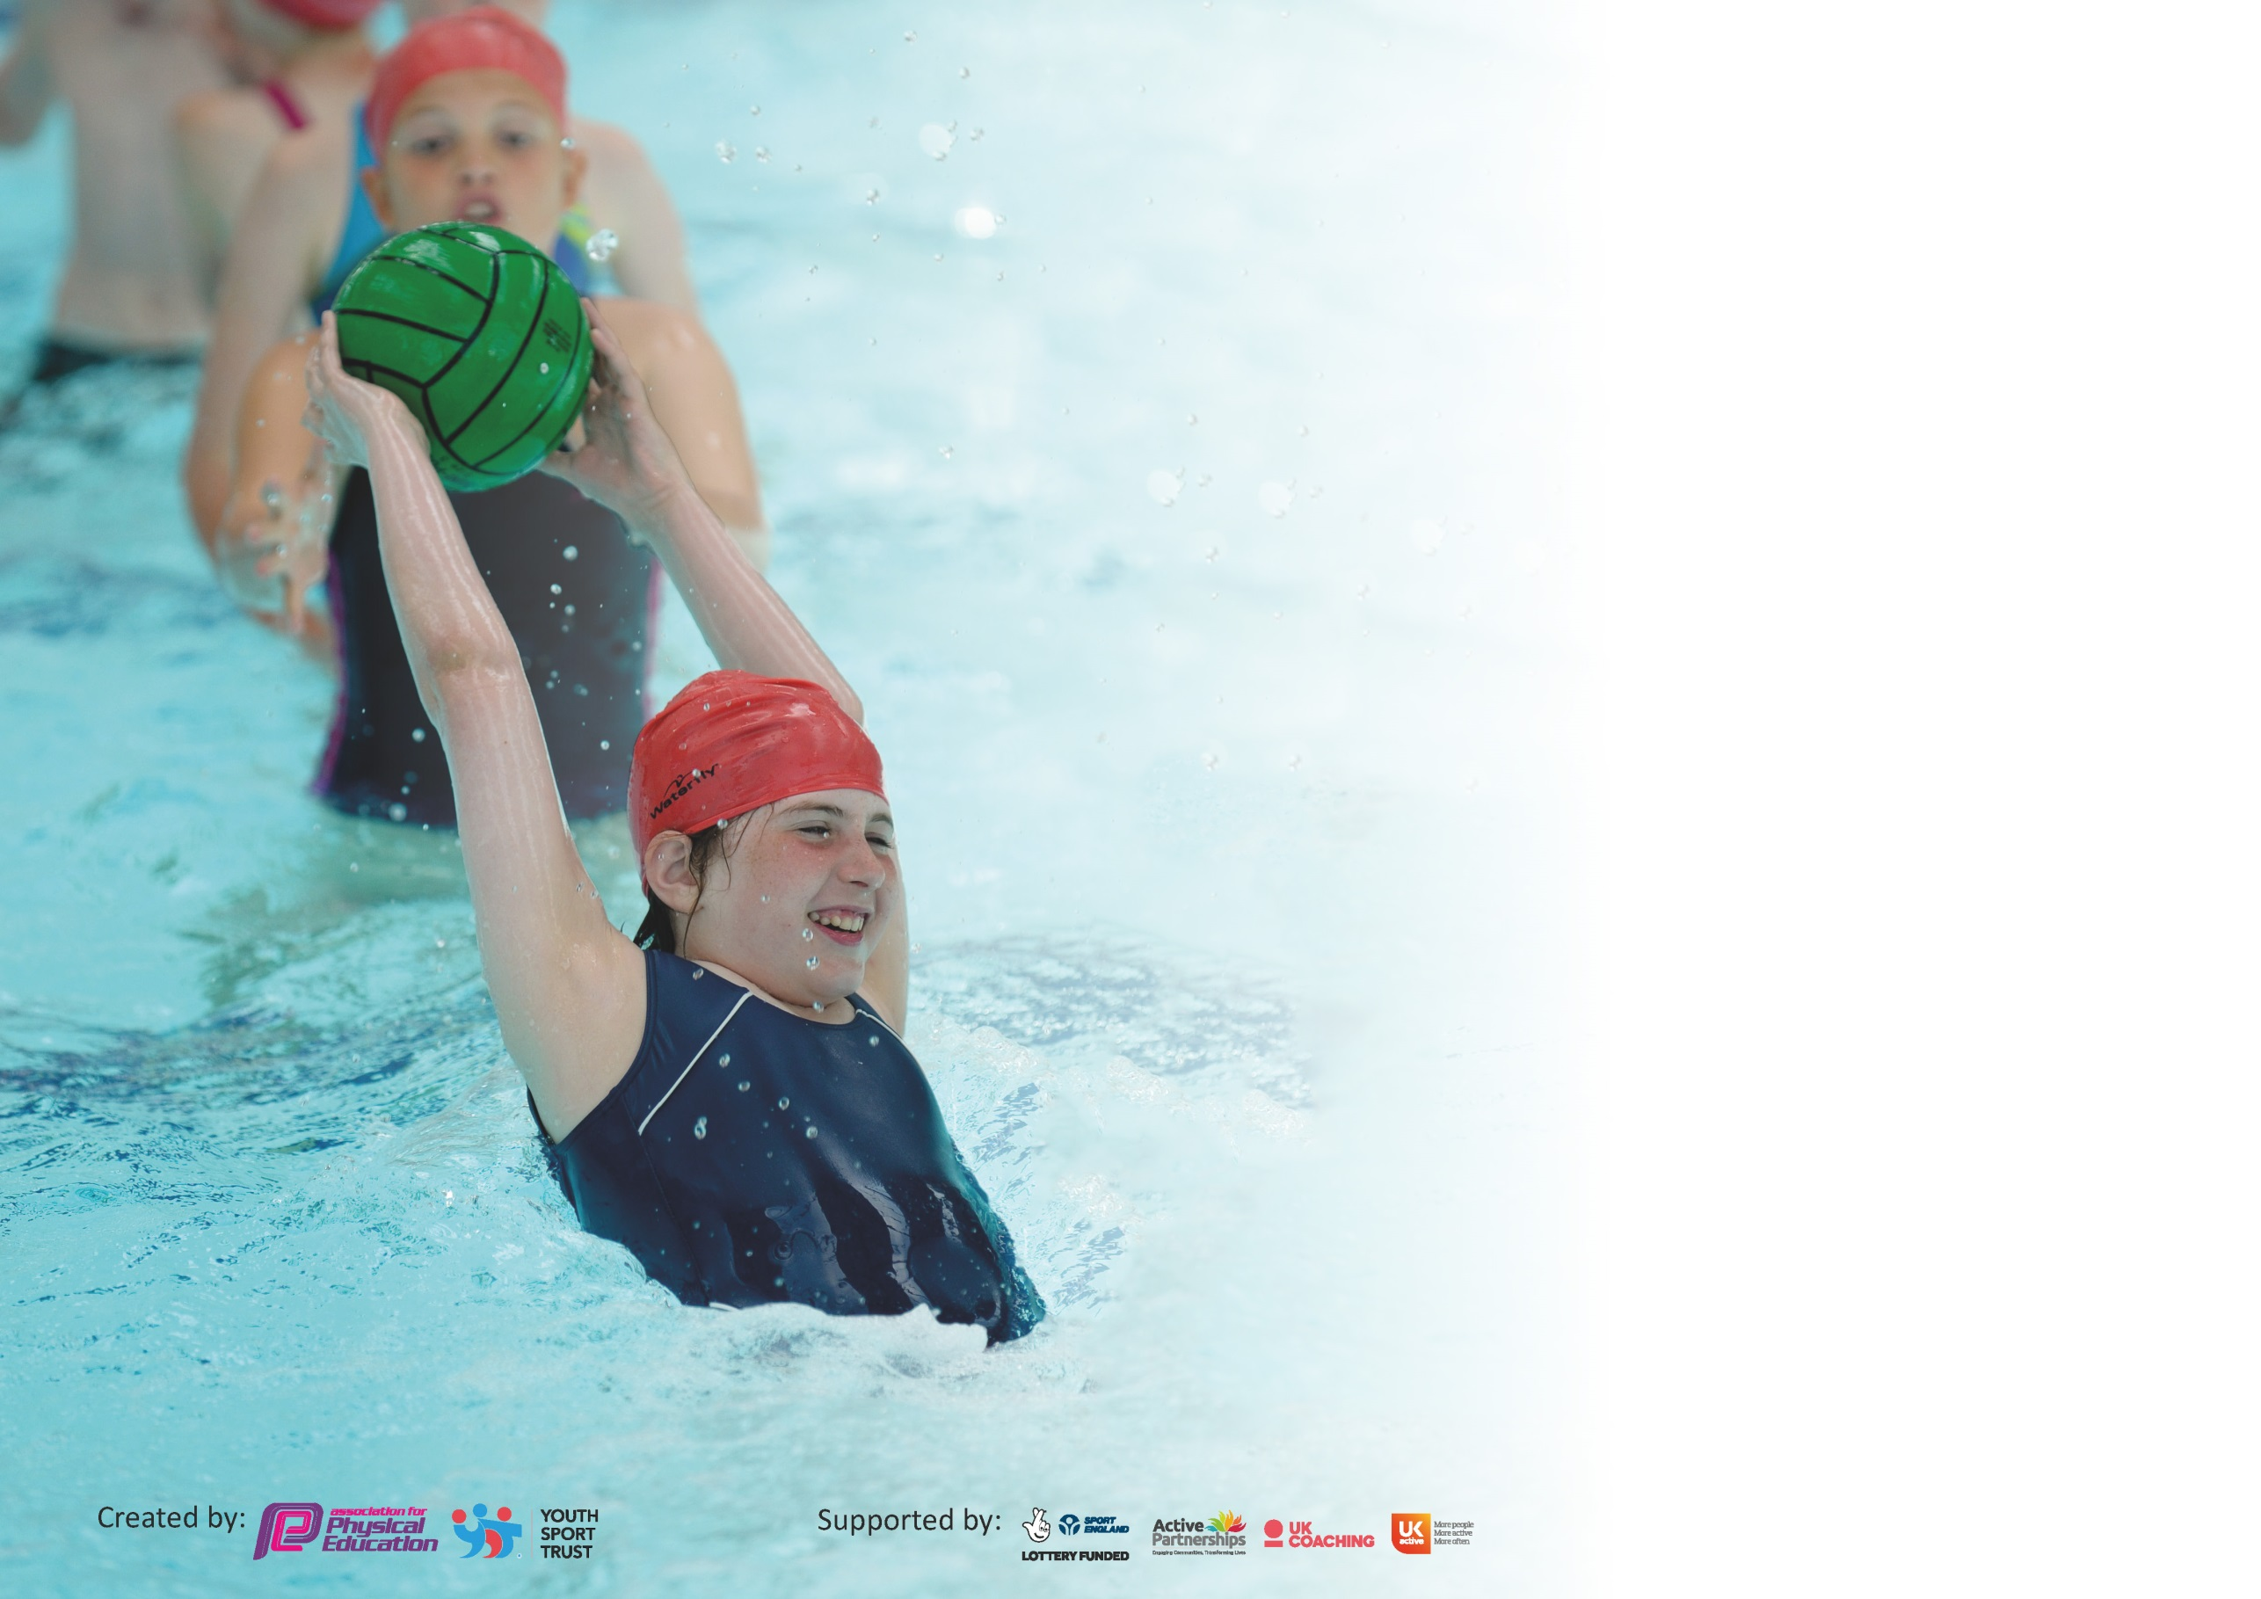

It is important that your grant is used effectively and based on school need. The Education Inspection Framework (Ofsted 2019 p64) makes clear there will be a focus on ‘whether leaders and those responsible for governors all understand their respective roles and perform these in a way that enhances the effectiveness of the school’.

Under the Quality of Education criteria (p41) inspectors consider the extent to which schools can articulate their curriculum (INTENT), construct their curriculum (IMPLEMENTATION) and demonstrate the outcomes which result (IMPACT).

To assist schools with common transferable language this template has been developed to utilise the same three headings which should make your plans easily transferable between working documents.

Schools must use the funding to make additional and sustainable improvements to the quality of Physical Education, School Sport and Physical Activity (PESSPA) they offer. This means that you should
use the Primary PE and Sport Premium to:

- Develop or add to the PESSPA activities that your school already offer
- Build capacity and capability within the school to ensure that improvements made now will benefit pupils joining the school in future years

Please visit gov.uk for the revised DfE guidance including the 5 key indicators across which schools should demonstrate an improvement. This document will help you to review your provision and to report your spend. DfE encourages schools to use this template as an effective way of meeting the reporting requirements of the Primary PE and Sport Premium.

We recommend you start by reflecting on the impact of current provision and reviewing the previous spend.

Schools are required to publish details of how they spend this funding as well as on the impact it has on pupils’ PE and sport participation and attainment by the end of the summer term or by 31st July 2020 at the latest.

We recommend regularly updating the table and publishing it on your website throughout the year. This evidences your ongoing self-evaluation of how you are using the funding to secure maximum, sustainable impact. Final copy must be posted on your website by the end of the academic year and no later than the 31st July 2020. To see an example of how to complete the table please click HERE.

Support for review and reflection - considering the 5 key indicators from DfE, what development needs are a priority for your setting and your pupils now and why? Use the space below to reflect on previous spend and key achievements and areas for development.

Key achievements to date until July 2019: | Areas for further improvement and baseline evidence of need:
Digital school games mark achieved.  Children have attended many sporting events, including some for the first time we have entered as a school (indoor football and basketball).  Equipment used in school is safe and effective.  Training opportunities have been attended and information given back to wider staff.  Afterschool clubs are well attended.  Daily mile is being implemented using track at play and dinner times. | After exams Year 6 children who have not achieved the national curriculum requirements for swimming and water safety will have additional swimming lessons, due to Covid-19 our usual swimming provision was cancelled, the additional provision should help our percentage to increase.

Meeting national curriculum requirements for swimming and water safety.
What percentage of your current Year 6 cohort swim competently, confidently and proficiently over a distance of at least 25 metres?  N.B. Even though your pupils may swim in another year please report on their attainment on leaving  primary school at the end of the summer term 2020. | 72%  (21/29)  No data for new starters and SEN
What percentage of your current Year 6 cohort use a range of strokes effectively [for example, front crawl, backstroke and breaststroke]? | 72%
What percentage of your current Year 6 cohort perform safe self-rescue in different water-based situations? | 72%
Schools can choose to use the Primary PE and Sport Premium to provide additional provision for swimming but this must be for activity over and above the national curriculum requirements. Have you used it in this way? | Yes/No

Action Plan and Budget Tracking
Capture your intended annual spend against the 5 key indicators. Clarify the success criteria and evidence of impact that you intend to measure to evaluate for pupils today and for the future.

Academic Year: 2019/20 | Total fund allocated: £ | Date Updated:
Key indicator 1: The engagement of all pupils in regular physical activity – Chief Medical Officer guidelines recommend that primary school pupils undertake at least 30 minutes of physical activity a day in school |  |  |  | Percentage of total allocation:
 |  |  |  | %
Intent | Implementation |  | Impact
Your school focus should be clear what you want the pupils to know and be able to do and about  what they need to learn and to  consolidate through practice: | Make sure your actions to achieve are linked to your intentions: | Funding allocated: | Evidence of impact: what do pupils now know and what can they now do? What has changed?: | Sustainability and suggested next steps:
Buying into KSSP, children will have access to competition across Kirkby and Knowsley with a variety of sports.  PE Passport app to be used across school as planning for the curriculum.  PE planning website accessible as secondary source of PE plans if needed. | KSSP with liaise with AW throughout the year, indicating the sporting competition opportunities available to Knowsley schools.  IT technician to ensure that the app is updated regularly across all teaching ipads. Training was provided September 2019. Refresh planned when visitors to school guidance has changed. | £1250  £599  £129 | The children have competed in many competitions throughout the year such as football, swimming, kurling and dodgeball.  PE teaching across the school has improved, the children are more engaged in lessons and are more active. | Millbrook will buy into KSSP again next year, entering as many competitions as possible following government guidelines.  Millbrook will continue to use the app in 2020/21.  PE planning will not be used.
Key indicator 2: The profile of PESSPA being raised across the school as a tool for whole school improvement |  |  |  | Percentage of total allocation:
 |  |  |  | %
Intent | Implementation |  | Impact
Your school focus should be clear what you want the pupils to know and be able to do and about  what they need to learn and to  consolidate through practice: | Make sure your actions to achieve are linked to your intentions: | Funding allocated: | Evidence of impact: what do pupils now know and what can they now do? What has changed?: | Sustainability and suggested next steps:
Funky feet music resources in nursery.  Teaching assistant employed to run afterschool clubs 5 days a week and to lead PE focus group of lower attaining children during their P.E lessons separate from the main group.  LFC foundation charity presence increased throughout the year. Leading P.E ad PSHE sessions across school with a visit from the club mascot and Champions League Trophy.  New PE kits ordered for school. | Funky feet music sessions for nursery children, giving a more structured approach to sessions.  Level of activity will increase in PE lessons and have more structure at playtimes with the guidance of an adult. Afterschool clubs will be well attended at no cost to parents.  LFC foundation coaches would work with two classes for one afternoon a week, followed by a KS2 afterschool club. They kicked off their presence in school with a whole school assembly followed by a class visit to each class with ‘Mighty Red’ the club mascot. They then led a PSHE lesson explaining the benefits of sport both on physical and mental health.  To ensure school uniform is at its highest standard and children can represent the school with pride at competitions we bought new P.E kits . | £70  £8000  £1500  (two terms)  £300 | Children enjoyed resources and having more structure to music.  Level of engagement from the lower attaining group improved. Afterschool clubs were consistently well attended.  The launch day was a great success. Afterschool club has been full to capacity from the beginning and engagement in P.E lessons has been great.  Less time getting changed and finding kits in lesson time. | Resource will be used again next year.  Teaching assistant has now left school for a new opportunity and to pursue a teaching degree.  Plan is in place in for this to continue next year when guidelines advise it is safe to do so.  Children will enter school in their P.E kits to ensure as few children as possible need to get changed. PE kits will be available for children without them and will be cleaned and stored safely.

Key indicator 3: Increased confidence, knowledge and skills of all staff in teaching PE and sport. |  |  |  | Percentage of total allocation:
 |  |  |  | %
Intent | Implementation |  | Impact
Your school focus should be clear | Make sure your actions to | Funding | Evidence of impact: what do | Sustainability and suggested
what you want the pupils to know | achieve are linked to your | allocated: | pupils now know and what | next steps:
and be able to do and about | intentions: |  | can they now do? What has
what they need to learn and to |  |  | changed?:
consolidate through practice:
CPD for staff training,  AW has been trained in active literacy. This has been taught in classes 7, 9 & 10 as a replacement for 1 guided reading session a week.  FA Active Play Through Storytelling course completed by KS1 staff.  Two teachers have received weekly CPD from LFC foundation coaches working with their classes weekly. | AW has rolled out an active literacy programme across KS2, this has been well received by pupils and staff.  Approaching story telling in KS1 in a more active way.  Two coaches work with the class teacher to deliver their P.E lesson for the week. | £300  £1500 | Active literacy session engaged learners very quickly. In year 3 the focus was improving use of adjectives, this improvement was clear after a few sessions.  More active approach now to story telling in KS1.  Teachers more confident in delivering P.E, pupils received high quality lessons. | Refresher course booked when safe to do so.  Active literacy to be continued across KS2.  When safe to do so this will continue in 2020/21.
Key indicator 4: Broader experience of a range of sports and activities offered to all pupils |  |  |  | Percentage of total allocation:
 |  |  |  | %
Intent | Implementation |  | Impact
Your school focus should be clear | Make sure your actions to | Funding | Evidence of impact: what do | Sustainability and suggested
what you want the pupils to know | achieve are linked to your | allocated: | pupils now know and what | next steps:
and be able to do and about | intentions: |  | can they now do? What has
what they need to learn and to |  |  | changed?:
consolidate through practice:
Afterschool sports clubs ran by TA. 5 days a week  LFC foundation multisports club weekly.  Weekly dance club rotating between KS1 & 2 every term.  High quality football goals bought for school field, potential opportunity for sporting events to take place at school.  Daily mile track painted on both infant and junior playground.  New equipment bought. | A range of sporting opportunities across all age groups in school, at no cost to parents.  KS2 group to engage as many older children in sports clubs. High quality coaching at no cost to parents.  Providing the children high quality dance lessons afterschool for free.  Friendly football matches played on grass being a possibility for the first time in several years.  This allows teachers the opportunity to complete the daily mile with their classes and allows for more structure at playtime.  Greater range of sports can be taught in PE lessons and in afterschool clubs. | £8000  £1500  £1140  £925  £1000  £1200 | Level of engagement from the lower attaining group improved. Afterschool clubs were consistently well attended.  All afterschool clubs very well attended.  More stock of PE equipment to deliver high quality lessons.  More opportunities for structured activity throughout the day for pupils. | Teaching assistant has now left school for a new opportunity and to pursue a teaching degree. Opportunities for afterschool clubs will be discussed in September 2020 following government guidelines on external visitors.  Dance and LFC foundation sessions will continue when safe.  When safe matches will be organised.  Within classroom bubbles they will use the daily mile track regularly during the timetable and at breaktime.

